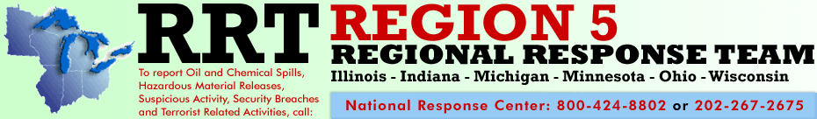

Spring Meeting, July 22-24, 2013
Illinois State Emergency Operations Center, Springfield, IL

Monday July 22, 2013

1:00 p.m. | Planning Subcommittee Meeting | Ann Whelan, USEPA
2:00 p.m. | S&T Subcommittee Meeting | USEPA
3:00 p.m.  4:00 p.m. | Training Subcommittee  Emergency Preparedness Task Force Update | Scott Binko, USCG  Tom Crane, GLC

Tuesday, July 23, 2013

8:00 a.m | Registration and Check-in
8:30 a.m. | Welcome and Introductions | Mr. Jerry Popiel, USCG  Mr. Jason El-Zein, USEPA
8:45 a.m.  10:00 a.m. | State and Federal Roundtable Reports  RRT5 New Website Rollout | Various  Ann Whelan, USEPA  Stuart Eddy, GLC
10:30 a.m. | Break
10:45 a.m. | RRT Website Tools | Ann Whelan, USEPA
11:30 a.m. | Overview of Endangered Species Act (ESA) Consultation Process | Mike Coffey, USFWS
12:00 p.m. | Lunch
1:00 p.m. | ESA Case Studies  - Informal Consultation  - Formal Consultation  - No Consultation | Mike Coffey, USFWS
2:30 p.m. | Break
3:00 p.m. | Tar Sands Presentation | NOAA/Academia
4:00 p.m. | Illinois State Emergency Operations Center Tour | Roger Lauder, IEPA
4:30 p.m.  5:30 p.m. | Wrap-up  Informal Social-Mahogany Bar and Grill, Crowne Plaza Hotel
Wednesday, July 24, 2013

8:30 a.m. | On Scene Coordinator Reports:  - Crooked Creek Fryer Oil Release  - Tug Hammond Response | Paul Atkociunas, USEPA  LT Mike Thompson, USCG
10:00 a.m. | USCG National Strike Force - Atlantic Strike Team Capabilities | CWO Dave Studer, USCG
10:30 a.m. | Break
10:45 a.m. | RRT5 GIS Comparisons/RULET Update/Oil in Ice Demonstration | Scott Binko, USCG
11:15 a.m. | Environmental Response Management Application (ERMA) | Ben Shorr, NOAA
12:00 p.m. | Lunch
1:00 p.m. | State Mutual for Environmental Response Update | Dorene Fier-Tucker, MPCA
1:30 p.m. | Subcommittee Reports  - Planning  - Science and Technology  - Training
2:30 p.m. | Pipeline and Hazardous Materials Safety Administration Mission Overview | PHMSA
3:00 p.m. | Co-Chairs Wrap-Up  - Proposed next meeting in Cleveland, Ohio (November) | Mr. Jerry Popiel, USCG  Mr. Jason El-Zein, USEPA

* For those not able to attend in person, participation will be available via adobe connect and conference line.

For all three days, (July 22-24)
Conference line 877-226-9607, code 3628518678

Adobe connect website:
July 22, 2013
https://epa.connectsolution.com/julyrrt

July 23, 2013
https://epa.connectsolution.com/julyrrtday2

July24, 2013
https://epaconnectionsolution.com/julyrrtday3

